Miguel Silva Part- E

W1945895

Tutor: Ebad Majeed Seminar: Tuesday 11am – 1pm

**CSS**

1. /* Miguel Silva CSS - w1945895 - Tutorial Tuesday 11am - 1pm - Teacher: Ebad Majeed*/
   * {
2. box-sizing: border-box;
3. }
4. body {
5. background-image: url(https://github.com/MysticMigz/Personal-Website-Project/blob/main/background.jpg?raw=true);
6. background-size: cover;
7. background-position: center;
8. color: white;
9. text-shadow: 2px 2px 3px black;
10. }
11. header {
12. width: 100%;
13. height: 50%;
14. background: linear-gradient(90deg, #0074D9, #00bc8c);
15. color: #fff;
16. text-align: center;
17. box-shadow: 0px 2px 4px rgba(0, 0, 0, 0.4);
18. }
19. .Brief-Description {
20. font-style: italic;
21. }
22. /* ----------- Negation Pseudo Class ------------*/
23. header:not(h1) {
24. color: midnightblue     /*Targets the h1*/
25. }
26. /* ---------------------------------------------*/
27. /* ----------- Relational Selector ------------*/
28. div>p {   /*Selects all direct children of div that are P elements. Any children with other elements (eg.section) inside div will not be selected*/
29. background: linear-gradient(90deg, lightskyblue, magenta);
30. border-radius: 5px;
31. }
32. /* ---------------------------------------------*/
33. header h1 {
34. padding: 20px;
35. }
36. .conatiner-nav {
37. padding: 10px 10%;
38. }
39. nav {
40. display: flex;
41. align-items: center;
42. justify-content: space-between;
43. flex-wrap: wrap
44. }
45. .logo {
46. width: 140px;
47. margin-bottom: 20px;
48. border: solid black;
49. border-radius: 10px;
50. margin-left: 20px;
51. }
52. nav ul li {
53. display: inline-block;
54. list-style: none;
55. margin: 10px 20px;
56. }
57. nav ul li a {
58. color: white;
59. text-decoration: none;
60. font-size: 30px;
61. position: relative;
62. font-family: 'BebasNeue-Regular', sans-serif;   /*Used the FontFace Here for Nav bar*/
63. }
64. nav ul li a::after {
65. content: '';
66. width: 0;
67. height: 3px;
68. background: linear-gradient(90deg, lightskyblue, magenta);
69. position: absolute;
70. left: 0;
71. bottom: -6px;
72. transition: 0.5s;   /* -------------Transitions used for small bar under Nav when hovered------------*/
73. }
74. nav ul li a:hover::after {
75. width: 100%;
76. }
77. .header-text {
78. font-size: 30px;
79. text-decoration: underline, bold;
80. margin-left: 20px;
81. text-align: center;
82. flex-direction: column;
83. justify-content: center;
84. align-items: center;
85. }
86. .header-text h1 {
87. font-size: 30px;
88. margin-top: 20px;
89. text-align: center;
90. flex: 1;
91. }
92. .header-text h1 span {
93. color: lightskyblue;
94. }
95. h1{
96. font-family: 'BebasNeue-Regular', sans-serif; /*Used the FontFace Here for h1*/
97. }
98. p{
99. font-family: 'BebasNeue-Regular', sans-serif;
100. font-size: 30px;
101. }
102. /* -----------------Full-Content-------------------*/
103. .Full-Content {
104. display: grid;
105. grid-template-columns: minmax(200px, auto) 1fr;
106. /* sidebar min width 200px and main content takes up the rest */
107. grid-template-rows: auto;
108. /* Rows size to content */
109. height: 100vh;
110. /* Use full viewport height */
111. gap: 20px;
112. /* Adds gaps between rows and columns */
113. margin-right: 30px;
114. }
115. /* Content styles */
116. .container-content {
117. grid-column: 2 / 3;
118. justify-content: center;
119. /* Center horizontally */
120. align-items: center;
121. /* Center vertically */
122. height: 100%;
123. }
124. /* -----------------Flip Animation-------------------*/
125. .flip-card {
126. perspective: 2000px;
127. width: 300px;
128. /* Adjust the width as needed */
129. height: 400px;
130. /* Adjust the height as needed */
131. margin: auto;
132. /* Centers the card in the available space */
133. }
134. .flip-card-inner {
135. position: relative;
136. width: 100%;
137. height: 100%;
138. text-align: center;
139. transition: transform 0.6s;
140. transform-style: preserve-3d;
141. }
142. .flip-card:hover .flip-card-inner {
143. transform: rotateY(180deg);
144. }
145. .flip-card-front,
146. .flip-card-back {
147. position: absolute;
148. width: 100%;
149. height: 100%;
150. backface-visibility: hidden;
151. }
152. .flip-card-front {
153. display: flex;
154. align-items: center;
155. justify-content: center;
156. }
157. .flip-card-back {
158. transform: rotateY(180deg);
159. }
160. .flip-card-front img,
161. .flip-card-back img {
162. width: 100%;
163. height: 100%;
164. object-fit: cover;
165. display: block;
166. border-radius: 50%;
167. padding-bottom: 20px;
168. }
169. /* ---------------Footer-----------------*/
170. footer {
171. background: linear-gradient(90deg, #0074D9, #00bc8c);
172. color: white;
173. text-align: center;
174. padding: 10px;
175. bottom: 0;
176. width: 100%;
177. box-shadow: 0 2px 5px rgba(0, 0, 0, 0.8);
178. }
179. /* -----------------Sidebar Styling-------------------*/
180. .sidebar {
181. width: 200px;
182. background: linear-gradient(90deg, lightskyblue, magenta);
183. color: #fff;
184. padding: 20px;
185. text-align: center;
186. display: flex;
187. height: 100%;
188. border: solid black;
189. border-radius: 10px;
190. grid-column: 1 / 2;
191. }
192. .social-icons a {
193. display: block;
194. margin-bottom: 15px;
195. text-decoration: none;
196. color: #fff;
197. }
198. .social-icons img {
199. width: 60px;
200. height: 60px;
201. margin-right: 10px;
202. opacity: 50%;
203. }
204. /* Added hover effect to the social icons */
205. .social-icons img:hover {
206. transition: 1s;
207. opacity: 100%;
208. }
209. .social-icons span {
210. display: inline-block;
211. font-size: 12px;
212. color: blue;
213. text-align: center;
214. font-family: 'Poppins', sans-serif;
215. }
216. /* -----------------About-------------------*/
217. .about-col-1 {
218. flex-basis: 35%;  /* Also adds responsiveness by setting initial size */
219. }
220. .about-col-1 img {
221. width: 100%;
222. border-radius: 15px;
223. }
224. .about-col-2 {
225. flex-basis: 60%;  /* Also adds responsiveness by setting initial size */
226. }
227. .progress-container {
228. width: 100%;
229. background-color: #f3f3f3;
230. padding: 10px;
231. border-radius: 10px;
232. box-shadow: 0 2px 5px rgba(0, 0, 0, 0.2);  /* subtle shadow */
233. margin-bottom: 20px;  /* Space below the container */
234. }
235. /* ----------Individual progress bar styling-------------- */
236. .progress-container :nth-child(1) {
237. background-color: orange;
238. color: white;
239. text-align: right;
240. padding: 10px 20px;
241. /* Padding inside the bars */
242. width: 90%;
243. /* Initial width to match the percentage */
244. border-radius: 5px;
245. /* Rounded corners for bars */
246. transition: width 1s ease-in-out;
247. /* Animation for bar growth */
248. position: relative;
249. /* For positioning the percentage label */
250. margin-bottom: 10px;
251. /* Space between bars */
252. }
253. .progress-container :nth-child(2) {
254. background-color: purple;
255. text-align: right;
256. padding: 10px 20px;
257. /* Padding inside the bars */
258. width: 80%;
259. /* Initial width */
260. border-radius: 5px;
261. /* Rounded corners for bars */
262. transition: width 1s ease-in-out;
263. /* Animation for bar growth */
264. position: relative;
265. /* For positioning the percentage label */
266. margin-bottom: 10px;
267. /* Space between bars */
268. }
269. .progress-container :nth-child(3) {
270. background-color: rgba(255,0,0,0.9);
271. /* Green background */
272. color: white;
273. text-align: right;
274. padding: 10px 20px;
275. /* Padding inside the bars */
276. width: 95%;
277. /* Initial width */
278. border-radius: 5px;
279. /* Rounded corners for bars */
280. transition: width 1s ease-in-out;
281. /* Animation for bar growth */
282. position: relative;
283. /* For positioning the percentage label */
284. margin-bottom: 10px;
285. /* Space between bars */
286. }
287. .progress-bar::after {
288. position: absolute;
289. right: 10px;  /* Positioning from the right */
290. top: 10px;  /* Positioning from the top */
291. }
292. /* Hover effect for bars */
293. .progress-bar:hover {
294. box-shadow: 0 1px 5px rgba(25, 25, 112, 0.6);
295. /* More pronounced shadow on hover */
296. }
297. main {
298. background: rgb(25, 25, 112);
299. margin-bottom: 20px;
300. padding: 20px;
301. border-radius: 5px;
302. box-shadow: 0 5px 10px rgba(0, 0, 0, 0.1);
303. }
304. .Container-Gallery {
305. display: flex;
306. flex-wrap: wrap;
307. justify-content: space-between;
308. gap: 10px;
309. }
310. .Container-Gallery .image {
311. flex: 1;
312. max-width: 100%;
313. margin-bottom: 10px;
314. }
315. .Container-Gallery img {
316. width: 100%;  /* This makes the image responsive and fit its container */
317. height: auto;  /* This keeps the image aspect ratio intact */
318. max-width: 100%; /* Ensures the image is not larger than the container */
319. max-height: 300px;
320. display: block;  /* Removes any extra space below the image that inline elements have */
321. border-radius: 5px;
322. }
323. /* -----------------Blog Page-------------------*/
324. #blog {
325. max-width: 700px;
326. margin: auto;
327. padding: 20px;
328. }
329. #blog h2 {
330. text-align: center;
331. margin-bottom: 20px;
332. }
333. article {
334. background: linear-gradient(90deg, #0074D9, #00bc8c);
335. margin-bottom: 20px;
336. padding: 20px;
337. border-radius: 5px;
338. box-shadow: 0 5px 10px rgba(0, 0, 0, 0.1);
339. }
340. article h3 {
341. border-bottom: 1px dashed #ccc;
342. padding-bottom: 10px;
343. margin-bottom: 10px;
344. }
345. article time {
346. font-style: italic;
347. font-size: 0.9em;
348. }
349. /* Easiest Way to scale images */
350. .ImageScaling {
351. object-fit: contain;
352. width: 100%;
353. border-radius: 5px;
354. }
355. /*----------------Contact Form Page------------------ */
356. h2 {
357. display: flex;
358. flex-direction: column;
359. align-items: center;
360. justify-content: center;
361. }
362. #contact-form {
363. display: flex;
364. flex-direction: column;
365. align-items: center;
366. justify-content: center;
367. min-height: 100vh;
368. }
369. form {
370. display: flex;
371. flex-direction: column;
372. width: 100%;
373. max-width: 500px;
374. }
375. label {
376. margin-top: 10px;
377. }
378. input[type="text"],
379. input[type="email"],
380. textarea {
381. width: 100%;
382. padding: 10px;
383. margin-top: 5px;
384. margin-bottom: 20px;
385. border: 1px solid #ccc;
386. border-radius: 5px;
387. }
388. input[type="submit"] {
389. width: auto;
390. padding: 10px 20px;
391. margin-top: 10px;
392. border: none;
393. border-radius: 5px;
394. background-color: #007bff;
395. color: white;
396. cursor: pointer;
397. }
398. input[type="submit"]:hover {
399. background-color: #0056b3;
400. }
401. /* ----------------- Validity styles for form elements --------------------*/
402. input:valid,
403. textarea:valid {
404. border: 2px solid green;
405. }
406. input:invalid,
407. textarea:invalid {
408. border: 2px solid red;
409. }
410. input[type="email"]:valid {
411. background-color: #DFF0D8;
412. }
413. input[type="email"]:invalid {
414. background-color: rgb(253, 251, 251);
415. }
416. /*--------------Bubbles Animation*------------*/
417. .bubbles img{
418. width: 50px;
419. animation: bubble 7s linear infinite;
420. }
421. .bubbles{
422. width: 100%;
423. display: flex;
424. align-items: center;
425. justify-content: space-around;
426. position: absolute;
427. bottom: -300px;
428. }
429. .bubbles img:nth-child(1){
430. animation-delay: 2s;
431. }
432. .bubbles img:nth-child(2){
433. animation-delay: 6s;
434. }
435. .bubbles img:nth-child(3){
436. animation-delay: 3s;
437. }
438. .bubbles img:nth-child(4){
439. animation-delay: 4.5s;
440. }
441. .bubbles img:nth-child(5){
442. animation-delay: 1s;
443. }
444. .bubbles img:nth-child(6){
445. animation-delay: 7s;
446. }
447. /*----------------Animation Keyframes------------------ */
448. @keyframes bubble{
449. 0%{
450. transform: translateY(0);
451. opacity: 0;
452. }
453. 50%{
454. opacity: 1;
455. }
456. 70%{
457. opacity: 1;
458. }
459. 100%{
460. transform: translateY(-80vh);
461. opacity: 0;
462. }
463. }
464. /*----------------Responsiveness------------------ */
465. @media screen and (max-width: 768px) {
466. .Full-Content {
467. flex-direction: column;
468. }
469. .sidebar,
470. .container-content {
471. width: 100%;
472. }
473. .content-flex {
474. flex-direction: column;
475. }
476. }
477. @media only screen and (max-width: 600px) {
478. /* Styles for small screens */
479. body {
480. font-size: 14px;
481. }
482. .container-nav nav ul {
483. flex-direction: column;
484. }
485. .header-text h1 {
486. font-size: 1.5rem;
487. }
488. article {
489. font-size: 14px;
490. }
491. header,
492. main,
493. footer {
494. padding: 10px;
495. }
496. .progress-container .progress-bar {
497. font-size: 14px;
498. }
499. .header-text h1 span {
500. color: red;
501. }
502. }
503. @media only screen and (min-width: 601px) and (max-width: 1024px) {
504. /* Styles for medium screens */
505. body {
506. font-size: 16px;
507. }
508. .container-nav nav ul {
509. flex-direction: row;
510. }
511. .header-text h1 {
512. font-size: 2rem;
513. }
514. article {
515. font-size: 16px;
516. }
517. header,
518. main,
519. footer {
520. padding: 20px;
521. }
522. .progress-container .progress-bar {
523. font-size: 16px;
524. }
525. .header-text h1 span {
526. color: green;
527. }
528. }
529. @media only screen and (min-width: 1025px) {
530. /* Styles for large screens */
531. body {
532. font-size: 18px;
533. }
534. .container-nav nav ul {
535. flex-direction: row;
536. }
537. .header-text h1 {
538. font-size: 2.5rem;
539. }
540. article {
541. font-size: 18px;
542. }
543. header,
544. main,
545. footer {
546. padding: 30px;
547. }
548. .progress-container .progress-bar {
549. font-size: 18px;
550. }
551. .header-text h1 span {
552. color: lightskyblue;
553. }
554. }
555. /*----------------Font Face------------------ */
556. @font-face {
557. font-family: 'BebasNeue-Regular';
558. font-weight: 700;
559. src: url(assets/BebasNeue-Regular.otf);
560. }
561. @font-face {
562. font-family: 'Roboto-Regular';
563. font-weight: 700;
564. src: url(assets/Roboto-Regular.ttf);
565. }

**-----------------------------------------------------------------------------------------------------------------------------------------------------------------------------**

**index.html**

<!DOCTYPE html>

<html lang="en">

<head>

    <meta charset="UTF-8">

    <meta name="viewport" content="width=device-width, initial-scale=1.0">

    <title>Personal Portfolio Website</title>

    <link rel="stylesheet" href="NewStyle.css">

</head>

<body>

    <!-- Main Page -->

    <header>

        <h1>Welcome to my Page</h1>

        <div class="container-nav">

            <nav>

                <img src="https://github.com/MysticMigz/Personal-Website-Project/blob/main/default.png?raw=true" class="logo" alt="logo">

                <ul>

                    <li><a href="index.html">Home</a></li>

                    <li><a href="AboutMePage.html">About</a></li>

                    <li><a href="blogpage.html">Blog</a></li>

                    <li><a href="contactform.html">Contact</a></li>

                </ul>

            </nav>

        </div>

    </header>

    <div class="Full-Content">

        <aside class="sidebar">

            <div class="social-icons">

                <a href="https://www.linkedin.com/in/miguel-silva-004b36250/" target="_blank">

                    <img src="https://raw.githubusercontent.com/MysticMigz/Personal-Website-Project/00cb553e6b4a11de5553084c6c774bed310e34b1/linkedin.svg" alt="LinkedIn">

                    <span>LinkedIn Profile</span>

                </a>

                <a href="https://www.instagram.com/miguelsilva5088/" target="_blank">

                    <img src="https://raw.githubusercontent.com/MysticMigz/Personal-Website-Project/00cb553e6b4a11de5553084c6c774bed310e34b1/instagram.svg" alt="Instagram">

                    <span>Instagram Profile</span>

                </a>

                <a href="https://www.facebook.com/profile.php?id=100002558094945" target="_blank">

                    <img src="https://raw.githubusercontent.com/MysticMigz/Personal-Website-Project/00cb553e6b4a11de5553084c6c774bed310e34b1/facebook-f.svg" alt="Facebook">

                    <span>Facebook Profile</span>

                </a>

            </div>

        </aside>

        <div class="container-content">

            <div class="header-text">

                <p>Student from University of Westminster</p>

                <h1>Hello, I'm <span>Miguel</span> <br> from London. Welcome to my Site!</h1>

            </div>

            <div class="flip-card">

                <div class="flip-card-inner">

                    <div class="flip-card-front">

                        <img src="https://github.com/MysticMigz/Personal-Website-Project/blob/main/suit2.png?raw=true" alt="Front Image">

                    </div>

                    <div class="flip-card-back">

                        <img src="https://github.com/MysticMigz/Personal-Website-Project/blob/main/1000001448.jpg?raw=true" alt="Back Image">

                    </div>

                </div>

            </div>

            <p class="Brief-Description">As a current student pursuing my BSc in Computer Science at the University of Westminster, I am actively engaged in

            acquiring in-depth knowledge and practical skills in website development, application creation, and game

            design. My commitment to detail and efficiency has shaped me into a proficient programmer, eager to

            contribute effectively in team settings. Fueled by a passion for coding and a relentless pursuit of learning

            new methodologies and techniques, I am enthusiastic about enhancing my expertise in the computing world.

            Although I am still in the learning phase, I am confident in my growing ability to make significant contributions

            to projects and the broader computing landscape.</p>

            <footer>

                <p>&copy; Miguel Silva 2023 Portfolio Website</p>

            </footer>

                <div class="bubbles">

                <img src="https://github.com/MysticMigz/Personal-Website-Project/blob/main/bubble.png?raw=true">

                <img src="https://github.com/MysticMigz/Personal-Website-Project/blob/main/bubble.png?raw=true">

                <img src="https://github.com/MysticMigz/Personal-Website-Project/blob/main/bubble.png?raw=true">

                <img src="https://github.com/MysticMigz/Personal-Website-Project/blob/main/bubble.png?raw=true">

                <img src="https://github.com/MysticMigz/Personal-Website-Project/blob/main/bubble.png?raw=true">

                <img src="https://github.com/MysticMigz/Personal-Website-Project/blob/main/bubble.png?raw=true">

                <img src="https://github.com/MysticMigz/Personal-Website-Project/blob/main/bubble.png?raw=true">

            </div>

        </div>

</body>

</html>

**contactform.html**

<!DOCTYPE html>

<html lang="en">

<head>

    <meta charset="UTF-8">

    <meta name="viewport" content="width=device-width, initial-scale=1.0">

    <title>Personal Portfolio Website</title>

    <link rel="stylesheet" href="NewStyle.css">

</head>

<body>

    <!-- Nav Bar -->

    <header>

        <h1>Contact Page</h1>

        <div class="container-nav">

            <nav>

                <img src="https://github.com/MysticMigz/Personal-Website-Project/blob/main/default.png?raw=true" class="logo">

                <ul>

                    <li><a href="index.html">Home</a></li>

                    <li><a href="AboutMePage.html">About</a></li>

                    <li><a href="blogpage.html">Blog</a></li>

                    <li><a href="contactform.html">Contact</a></li>

                </ul>

            </nav>

        </div>

    </header>

    <main>

        <!-- Contact Page -->

        <h2>Contact Me</h2>

        <section id="contact-form">

            <h3>If you wish to reach me, please send me a message!</h3>

            <form action="submit_form.php" method="post">

                <!-- HTML5 form elements for registration and messaging -->

                <label for="name">Name:</label>

                <input type="text" id="name" name="name" required>

                <label for="email">Email:</label>

                <input type="email" id="email" name="email" required placeholder="example@example.com">

                <label for="message">Message:</label>

                <textarea id="message" name="message" required></textarea>

                <input type="submit" value="Submit">

            </form>

        </section>

        <footer>

            <p>&copy; Miguel Silva 2023 Portfolio Website</p>

        </footer>

    </main>

</body>

</html>

**blogpage.html**

<!DOCTYPE html>

<html lang="en">

<head>

    <meta charset="UTF-8">

    <meta name="viewport" content="width=device-width, initial-scale=1.0">

    <title>Personal Portfolio Website</title>

    <link rel="stylesheet" href="NewStyle.css">

</head>

<body>

    <!-- Main Page -->

    <header>

        <h1>Blog Page</h1>

        <div class="container-nav">

            <nav>

                <img src="https://github.com/MysticMigz/Personal-Website-Project/blob/main/default.png?raw=true" class="logo">

                <ul>

                    <li><a href="index.html">Home</a></li>

                    <li><a href="AboutMePage.html">About</a></li>

                    <li><a href="blogpage.html">Blog</a></li>

                    <li><a href="contactform.html">Contact</a></li>

                </ul>

            </nav>

        </div>

    </header>

    <main>

        <!-- Blog Page -->

        <section id="blog">

            <h2>Blog</h2>

            <article>

                <h3>Travel</h3>

                <h2>Intro</h2>

                <img class="ImageScaling" src="https://github.com/MysticMigz/Personal-Website-Project/blob/main/1000001448.jpg?raw=true">

                <p>Welcome to my travel guide on two incredible destinations: Italy and Portugal.

                    As an avid traveller, I have been fortunate enough to visit many countries, but there is something

                    special about these two countries that captured my heart. From the bustling cities to the quaint

                    villages, Italy and Portugal offer a unique blend of history, culture, and stunning landscapes. Join

                    me as I take you on a journey through these two beautiful countries, sharing my tips and experiences

                    along the way. Let's travel together and discover the wonders of Italy and Portugal.</p>

                <h2>Delving into the Enchanting Italian Lifestyle: Experiences in Milan</h2>

                <img class="ImageScaling"

                    src="https://media.istockphoto.com/id/910002788/photo/the-piazza-del-duomo-at-dawn.jpg?s=612x612&w=is&k=20&c=0mRE636qM27up6HfGUU4yI9Eie--Hmz7uC8B6PSZr9I=">

                <p>Milan, the fashion capital of Italy, is a city that exudes elegance and charm. From the moment you

                    step foot in this enchanting city, you'll be captivated by its vibrant atmosphere and rich history.

                    One of the highlights of my trip to Milan was exploring the city's stunning landmarks and

                    sculptures. The Duomo di Milano, with its intricate Gothic architecture, is a sight to behold. The

                    imposing structure is a testament to the city's grandeur and beauty. Another must-visit landmark is

                    the Galleria Vittorio Emanuele II, a breathtaking shopping arcade that showcases the best of Italian

                    luxury.

                    In addition to its architectural wonders, Milan offers a vibrant nightlife scene. The city is home

                    to numerous clubs and bars where you can dance the night away. Whether you're a fan of electronic

                    music or prefer a more laid-back atmosphere, Milan has something for everyone.

                    For outdoor enthusiasts, Milan also boasts beautiful parks and a nearby lake. You can enjoy a

                    leisurely stroll through Parco Sempione or go kayaking on Lake Como, just a short distance away from

                    the city.

                </p>

                <h2>Navigating Albufeira and Visiting Benagil Cave</h2>

                <img class="ImageScaling"

                    src="https://media.gettyimages.com/id/1152850401/photo/benagil-cave-algarve-portugal-sup-boards-and-beach.jpg?s=612x612&w=gi&k=20&c=fYOpMvpI4pdcjXnhChATOUExoJhId2ZFz26CMn09Xhc=">

                <p>Albufeira, a popular coastal city in Portugal's Algarve region, is a must-visit destination for beach

                    lovers and outdoor enthusiasts. Known for its stunning beaches and vibrant nightlife, Albufeira

                    offers a diverse range of activities for every traveller. From lounging on the golden sands of Praia

                    dos Pescadores to exploring the bustling marina, there is no shortage of things to see and do in

                    this lively city.

                    One of the highlights of a trip to Albufeira is a visit to the famous Benagil Cave. This unique

                    natural wonder, located just a short distance from the city, is a must-see for any adventurer. Known

                    for its dramatic rock formations and crystal-clear waters, the cave can be explored by boat or

                    kayak. As you venture inside the cave, you'll be awe-struck by the stunning rock formations and the

                    sunlight streaming through the natural skylight. It's an experience that will leave you speechless

                    and provide unforgettable memories.

                    Navigating Albufeira is a breeze, thanks to its well-developed transport system. The city has a

                    reliable bus network that connects different areas, making it easy to explore all the attractions.

                    Taxis are also readily available for convenient transportation. If you prefer to be more

                    independent, hiring a car is a great option, allowing you to explore the surrounding areas at your

                    own pace.

                    Whether you're seeking adventure or simply looking to relax on the beach, Albufeira and the Benagil

                    Cave offer a perfect combination of natural beauty and vibrant city life. So, grab your sun hat,

                    pack your swimwear, and get ready for an incredible journey through Albufeira and the stunning

                    Benagil Cave.

                </p>

                <h2>Savouring the Authentic Flavours: A Foodie's Journey through Italy and Portugal</h2>

                <img class="ImageScaling"

                    src="https://media.gettyimages.com/id/1412465061/photo/flat-lay-of-family-dinner-table-with-italian-food.jpg?s=612x612&w=gi&k=20&c=QQ0usa7qRzpuJbJ_m0UgmyNlmPb9efl13Mk8J80AG_E=">

                <p>Indulge your taste buds and embark on a culinary adventure through Italy and Portugal, two countries

                    renowned for their gastronomic delights. Italy, known for its world-class cuisine, offers an array

                    of dishes that will tantalise your senses. From traditional pizzas in Naples to creamy gelato in

                    Florence, every region has its own culinary specialities waiting to be savoured. Make sure to try

                    the rich pasta dishes of Bologna, the seafood delicacies of Sicily, and the mouth-watering cannoli

                    in Palermo.

                    In Portugal, prepare to be amazed by the bold and diverse flavours that await you. Taste the famous

                    pasteis de nata in Lisbon, indulge in a hearty bowl of caldo verde soup, or enjoy a sumptuous plate

                    of grilled sardines in Porto. Don't forget to sample the renowned Bacalhau, Portugal's beloved

                    salted cod dish, and pair it with a glass of Vinho Verde or Port wine.

                    Whether you prefer savoury or sweet, Italy and Portugal offer a wide range of culinary delights that

                    will satisfy even the most discerning foodie. So come along and let your taste buds be transported

                    on a foodie journey through these incredible countries.

                </p>

                <h2>Cultural Exploration: Unearthing History and Art in Italy and Portugal</h2>

                <img class="ImageScaling"

                    src=https://media.gettyimages.com/id/1401374268/photo/porto-cityscape-at-sunset-with-tower-of-porto-town-hall-in-the-center-portugal.jpg?s=2048x2048&w=gi&k=20&c=ePgfetHhBZvqWHqT-SJRMG_dr-lSOpe06Cr2dRYcum4=>

                <p>Italy and Portugal are rich in history and culture, making them perfect destinations for cultural

                    exploration. In Italy, you can delve into the ancient world by visiting iconic sites such as the

                    Colosseum in Rome or the ruins of Pompeii. Discover the Renaissance in Florence, where you can

                    admire magnificent works of art by masters like Michelangelo and Botticelli. Italy is also home to

                    numerous museums and galleries, such as the Uffizi Gallery in Florence or the Vatican Museums in

                    Rome, where you can immerse yourself in the beauty of Italian art.

                    In Portugal, you can uncover a fascinating blend of history and art. Visit the historic district of

                    Belem in Lisbon, where you can explore the stunning Jeronimos Monastery and the Belem Tower, both

                    UNESCO World Heritage sites. In Porto, you can admire the beautiful azulejo tiles that decorate many

                    of the city's buildings, depicting scenes from Portuguese history and culture. The Calouste

                    Gulbenkian Museum in Lisbon showcases an impressive collection of European and Oriental art, whilst

                    the Serralves Museum in Porto features contemporary art exhibitions.

                    Both Italy and Portugal offer a wealth of historical and artistic treasures that will captivate any

                    cultural enthusiast. Take the time to explore these countries' museums, landmarks, and art

                    galleries, and you will be rewarded with a deeper understanding of their rich cultural heritage.

                </p>

                <time datetime="2023-05-22">Publication Date: 2023-05-22</time>

            </article>

            <article>

                <h3>Hobbies</h3>

                <h2>Intro</h2>

                <img class="ImageScaling"

                    src="https://media.gettyimages.com/id/1458841552/photo/elevated-drone-view-of-an-adventure-cyclist-on-his-gravel-bike-in-the-forest-on-a-cold-but.jpg?s=2048x2048&w=gi&k=20&c=v_8bEhkGvBUvYEu-04S72loRdB96vWhvYil8aMRY6Bw=">

                <p>Welcome to my blog, fellow hobby enthusiasts!

                    Today, I want to talk about the importance of pursuing our hobbies and how they contribute to our

                    overall happiness.

                    In a fast-paced world filled with responsibilities and obligations, it's easy to overlook the value

                    of taking time for ourselves and indulging in our passions.

                    However, I truly believe that our hobbies are not just mere pastimes, but rather essential for our

                    well-being.

                    So, let's dive into why hobbies are the key to our happiness.

                </p>

                <h2>The Powerful Connection between Hobbies and Happiness</h2>

                <img class="ImageScaling"

                    src="https://media.gettyimages.com/id/947551998/photo/boys-help-each-other-across-tidal-pools-at-sunset.jpg?s=1024x1024&w=gi&k=20&c=lugLP8_Z81m-MnoBanV1XkdBWgn7hsSJF7XEX_K0Suo=">

                <p>Our hobbies have a profound impact on our happiness and well-being.

                    Engaging in activities we love, such as football, gaming, crypto, or rock climbing, allows us to

                    experience joy, fulfilment, and a sense of accomplishment.

                    When we immerse ourselves in our hobbies, we enter a state of flow, where time seems to fly by, and

                    we are completely absorbed in the present moment.

                    This flow state promotes positive emotions and reduces stress, leading to an overall increase in

                    happiness.

                    Moreover, hobbies provide us with a much-needed escape from the demands of everyday life, allowing

                    us to recharge and rejuvenate.

                    By making time for our hobbies, we prioritise self-care and nurture our own happiness, ultimately

                    leading to a more fulfilled and balanced life.

                    So, let's make the most of our passions and unlock the powerful connection between hobbies and

                    happiness!

                </p>

                <h2>Making Magic with my Hobbies</h2>

                <img class="ImageScaling"

                    src="https://media.gettyimages.com/id/1779901392/photo/tottenham-hotspur-v-chelsea-fc-premier-league.jpg?s=2048x2048&w=gi&k=20&c=u_4XWU9JMz1cEiCzqDSeg9DChrit46xXjYJW5dSzTrY=">

                <p>My hobbies have always been a source of magic and excitement in my life.

                    Whether it's the adrenaline rush of playing football, the thrill of exploring new virtual worlds

                    through gaming, the fascination with the world of cryptocurrency, or the sense of achievement I get

                    from conquering new heights while rock climbing, each hobby has its own special kind of magic.

                    When I engage in these activities, I feel like I'm transported to a different realm where all my

                    worries and stresses fade away.

                    The intense focus required in football or gaming allows me to escape from the outside world and

                    immerse myself fully in the present moment.

                    The challenge of understanding the intricacies of cryptocurrency gives me a sense of adventure and

                    discovery.

                    And when I'm scaling a rock wall, I feel an incredible sense of accomplishment and awe at the beauty

                    of nature.

                    These hobbies bring me pure joy, and that joy has a ripple effect on all aspects of my life.

                    It's as if they infuse my everyday routine with a bit of enchantment and wonder.

                    They remind me to never stop exploring, to embrace my passions wholeheartedly, and to always make

                    time for the things that truly make me happy.

                    So, let's embrace the magic that our hobbies bring and create our own moments of joy and fulfilment.

                    After all, it's these moments that make life truly worth living.

                </p>

                <time datetime="2023-06-15">Publication Date: 2023-06-15</time>

            </article>

        </section>

    </main>

    <footer>

        <p>&copy; Miguel Silva 2023 Portfolio Website</p>

    </footer>

</body>

</html>

**AboutMePage.html**

<!DOCTYPE html>

<html lang="en">

<head>

    <meta charset="UTF-8">

    <meta name="viewport" content="width=device-width, initial-scale=1.0">

    <title>Personal Portfolio Website</title>

    <link rel="stylesheet" href="NewStyle.css">

</head>

<body>

    <header>

        <h1>About Me</h1>

        <div class="container-nav">

            <nav>

                <img src="https://github.com/MysticMigz/Personal-Website-Project/blob/main/default.png?raw=true" class="logo">

                <ul>

                    <li><a href="index.html">Home</a></li>

                    <li><a href="AboutMePage.html">About</a></li>

                    <li><a href="blogpage.html">Blog</a></li>

                    <li><a href="contactform.html">Contact</a></li>

                </ul>

            </nav>

        </div>

    </header>

    <main>

        <section id="intro">

            <h2>Some Insight About Me</h2>

            <p> Hi my names Miguel, I am a dynamic individual whose life is an exhilarating journey filled with a

                profound love for travel.

                My adventurous spirit has taken me to various corners of the world, exploring diverse cultures and

                landscapes.

                Beyond my wanderlust, I am also an avid enthusiast of rock climbing and football, finding solace and

                exhilaration in the great outdoors.

                When I am not scaling walls or cheering on my favorite team, I channel my creative energy into the realm

                of front-end development, crafting visually appealing and user-friendly digital experiences.

                I am confident enough to say that I am visionary at heart. I nurture a deep passion for designing

                innovative and novel creations, constantly seeking to push the boundaries of my creative capabilities.

            </p>

        </section>

        <section id="images">

            <h2>Photo Gallery</h2>

            <div class="Container-Gallery">

                <div class="image">

                    <img src="https://github.com/MysticMigz/Personal-Website-Project/blob/main/Scenary%203.jpg?raw=true" alt="Image 1">

                </div>

                <div class="image">

                    <img src= "https://github.com/MysticMigz/Personal-Website-Project/blob/main/Scenary%201.jpg?raw=true" alt="Scenary 1">

                </div>

                <div class="image">

                    <img src="https://github.com/MysticMigz/Personal-Website-Project/blob/main/Scenary%204.jpg?raw=true"  alt="Image 3">

                </div>

            </div>

        </section>

        <h2>Skills</h2>

        <section class="progress-container">

            <div class="progress-bar">CSS - 90%</div>

            <div class="progress-bar">JavaScript - 80%</div>

            <div class="progress-bar">HTML - 95%</div>

        </section>

        <footer>

            <p>&copy; Miguel Silva 2023 Portfolio Website</p>

        </footer>

    </main>

</body>

</html>

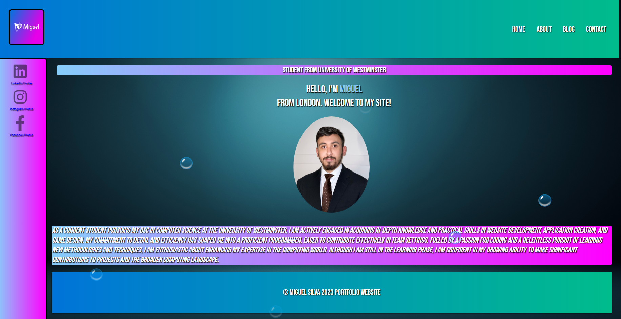

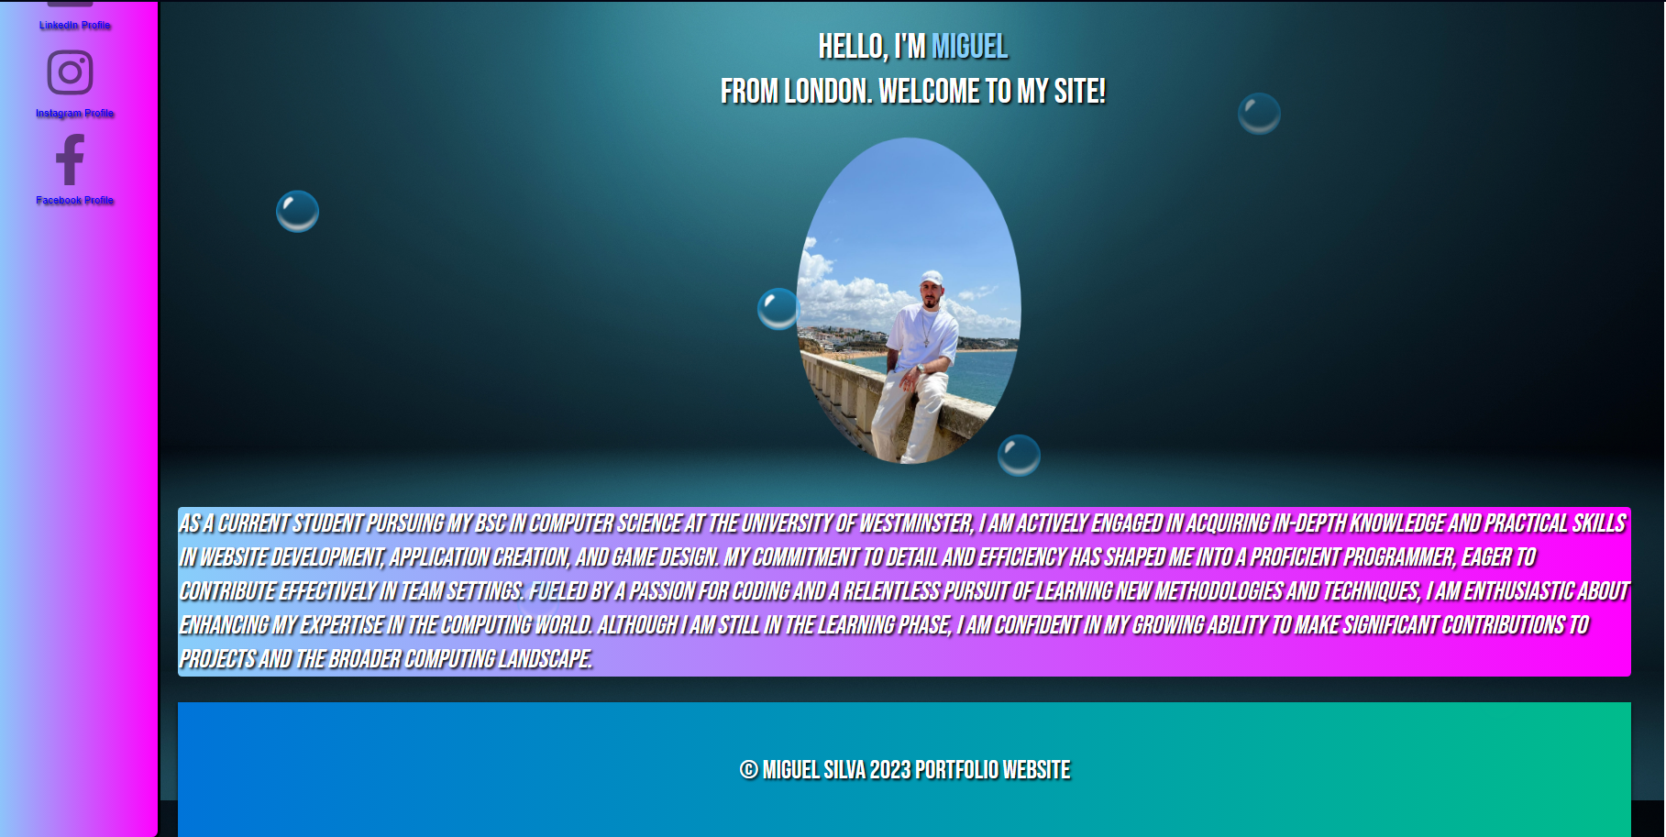

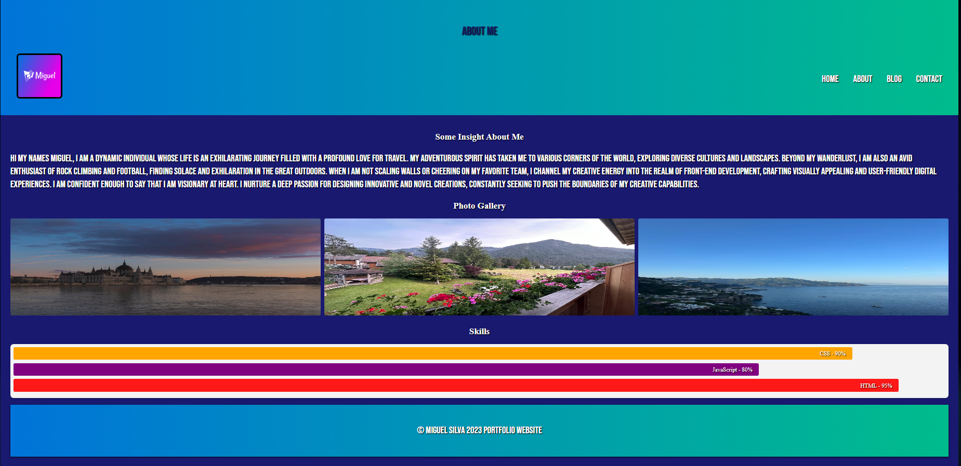

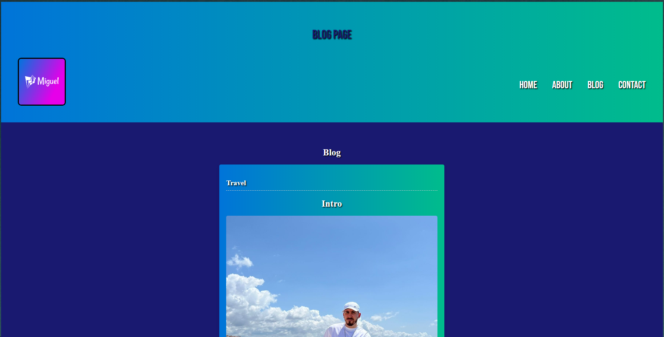

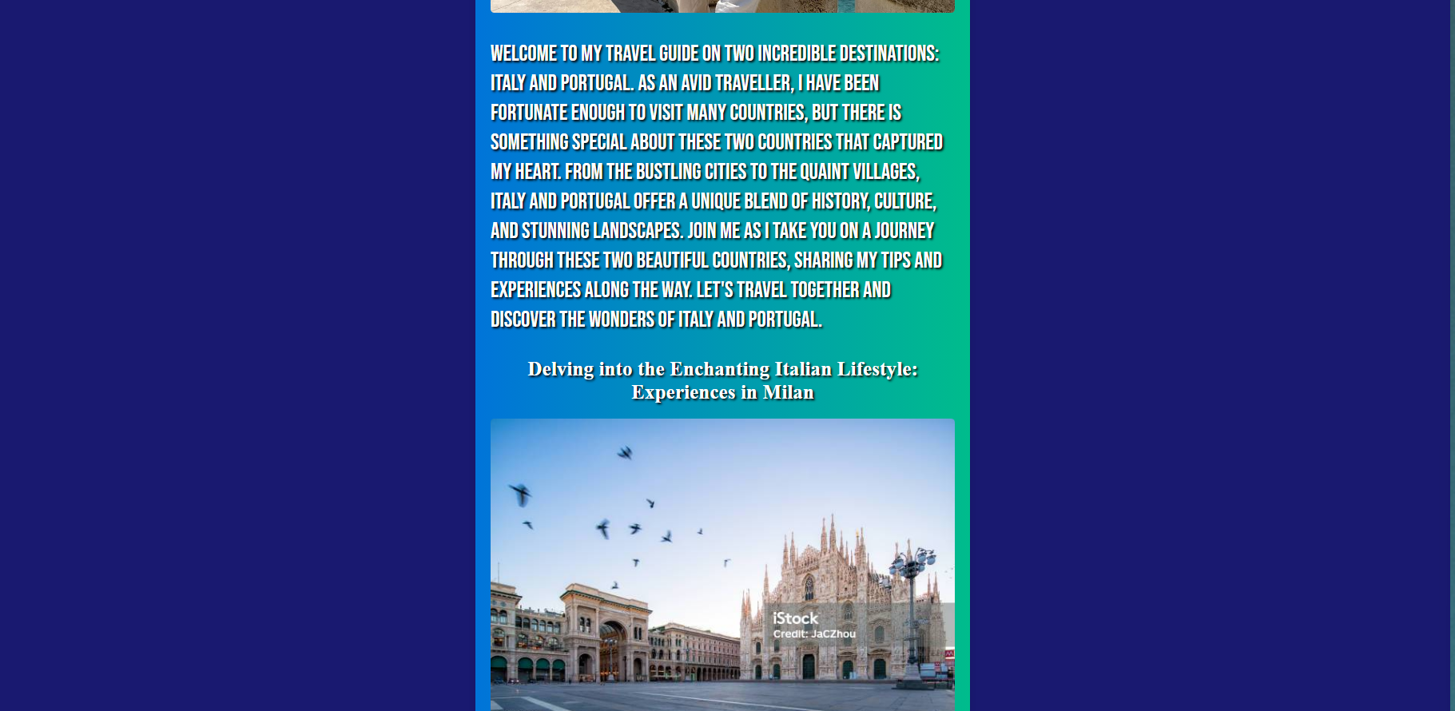

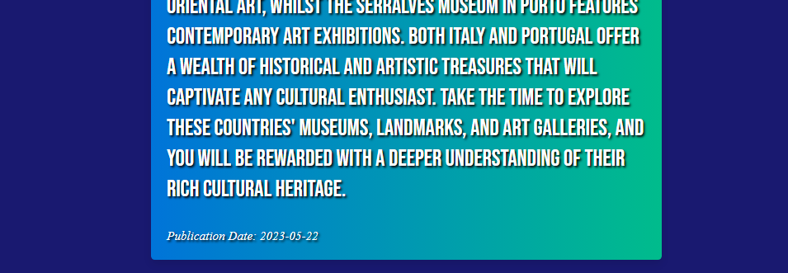

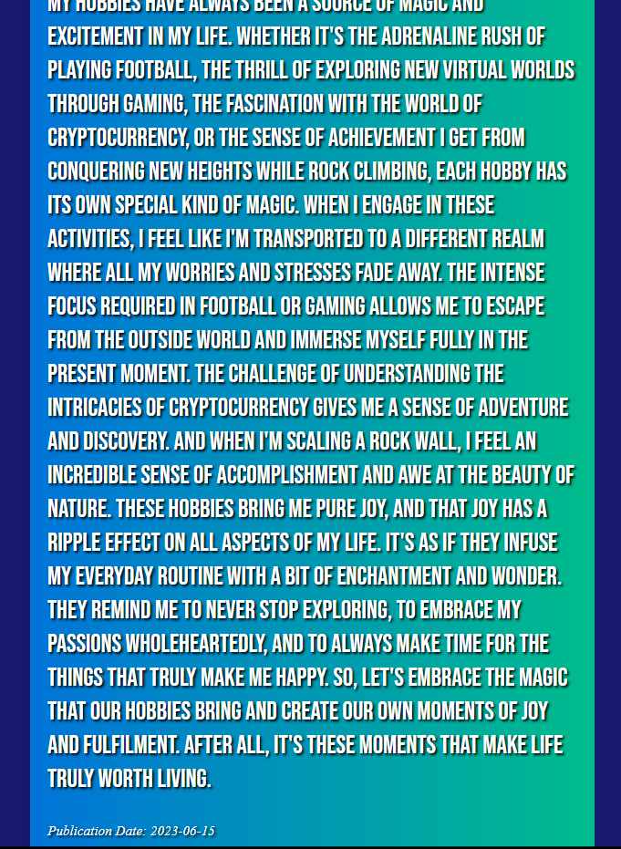

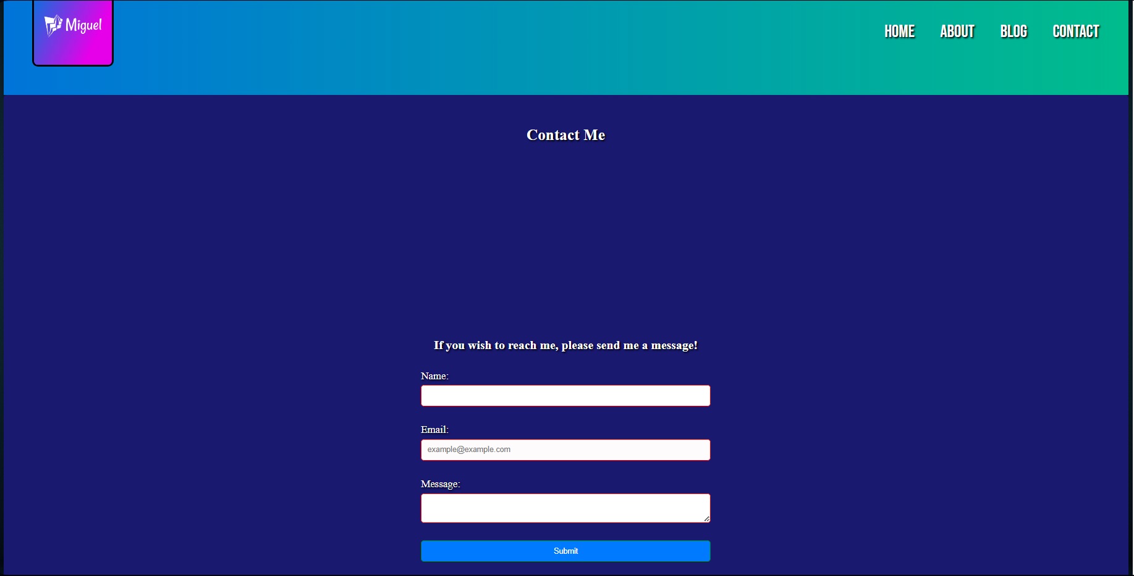

**DIARY**

**Webpage Portfolio Diary**

Miguel Silva

W1945895 - Seminar slot Tuesday 11am – 1pm

Tutor - Ebad Majeed

Week 1: 29th September 2023

Implemented the barebones of the website for the Home Page

* Nav Bar
* Content
* Sidebar
* Linked my social media
* Styled the Body for all pages

Week 2: 5th October 2023

* Constructed the layout of the page using grid method
* Completed the CSS for the Side bar, Nav Bar, Body and Header

Summary:

I was able to successfully produce a linear gradient background for my header. I produced the CSS transition for the nav bar. Also added my own logo to the page. Managed to source my images for the social media icons. Created the hover effect for the icons so that they transition from 50% opacity to 100% opacity.

Week 3: 12th October 2023

Contact Form:

* Produced the content for the Form webpage
* Styled the Contact Form Page
* Implemented the Validity pseudo class CSS

Implemented the validity pseudo class on the form with appropriate colour styling so that if its not correct it appears red, if correct it turns green. Styled the boxes so that they are clear and easy to see.

Blog Page:

* Created an article
* Uploaded images for the article and added the content
* Styled the blog page with blue background and border box

Week 4: 19th October 2023

Flip Transformation

* Implemented the flip transformation on an image to another image in the home page
* Added the Font Face for some two of the font-families that I have used for the site

Summary:

I was able to successfully setup the flip animation for the Home page and created a well-crafted blog page with content.

Week 5: 26th October 2023

Utilised the Nth term pseudo class  
Implemented the progression bar styling with the Nth child pseudo class

Week 6: 2nd November 2023

Media Responsiveness and Animations

Implemented all appropriate media queries for small, medium and large devices. Added the animation Key frames for the bubbles on my home page as they move from the bottom to the top slowly become opaquer until completely invisible.

Summary:

Overall, I have completed all sections of my website and optimised it well for media responsiveness. I have successfully used all of the mentioned requirements from the spec.